Test Case: runTestMultipleTimes
Step 1 - Enter username and password and click to button Enter : Credentials Entered
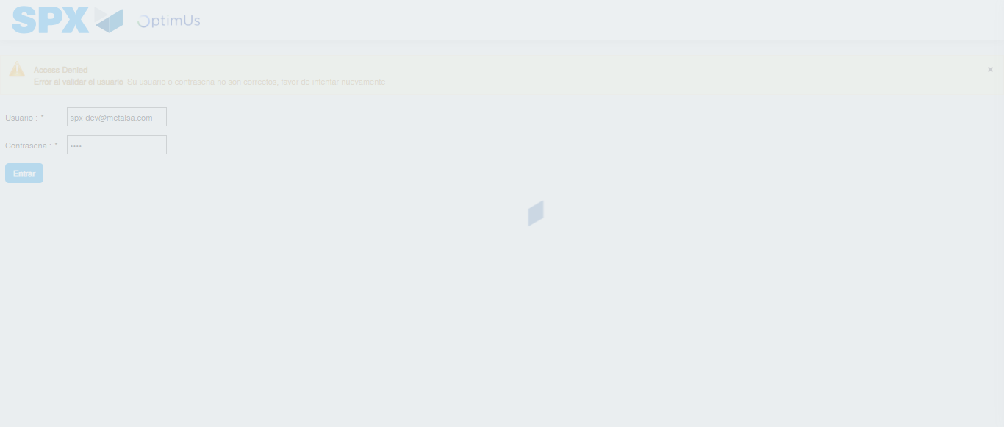Image file-name: QC_Testing-runTestMultipleTimes-nov. 25 2025, 03 47 47 p. m.

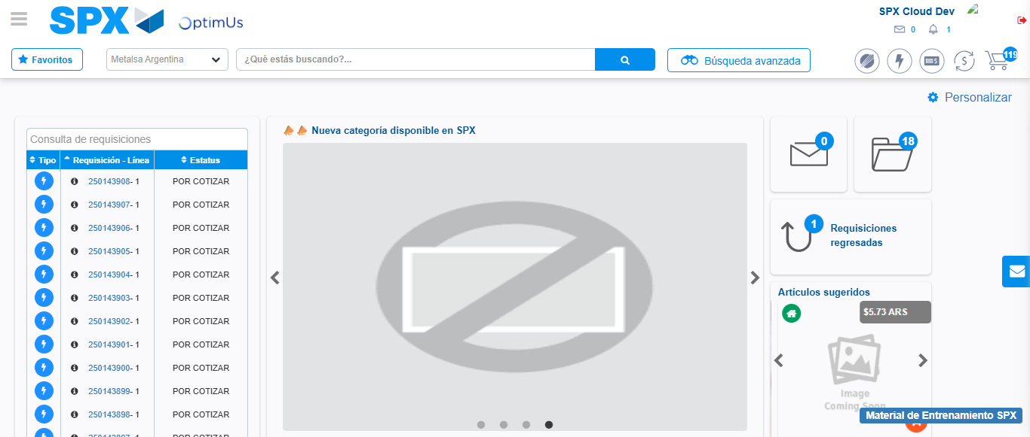Image file-name: QC_Testing-runTestMultipleTimes-nov. 25 2025, 03 49 20 p. m.

Step 2 - Select to UEN and Access to Spot Buy Requisitions : UEN Correctly selected and Correct access
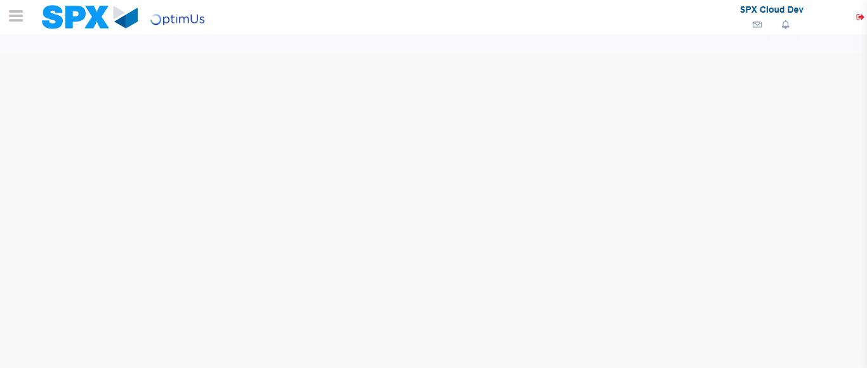Image file-name: QC_Testing-runTestMultipleTimes-nov. 25 2025, 03 47 50 p. m.

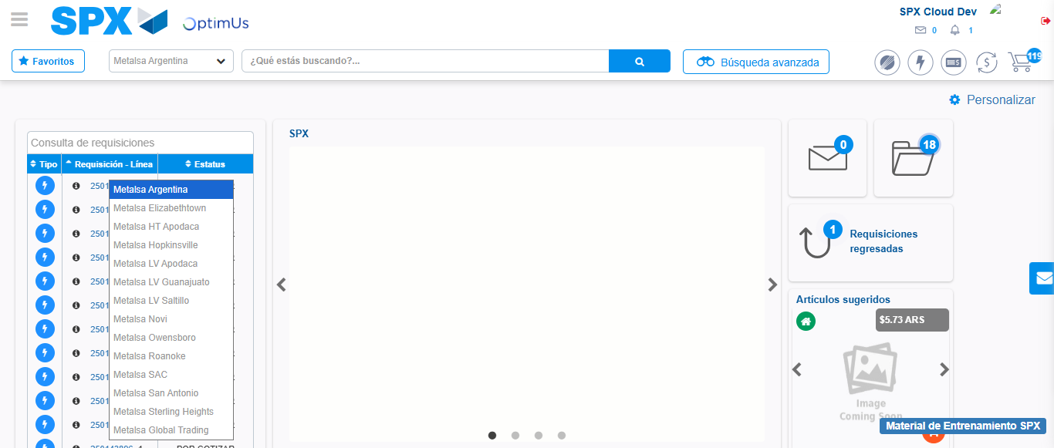Image file-name: QC_Testing-runTestMultipleTimes-nov. 25 2025, 03 47 51 p. m.

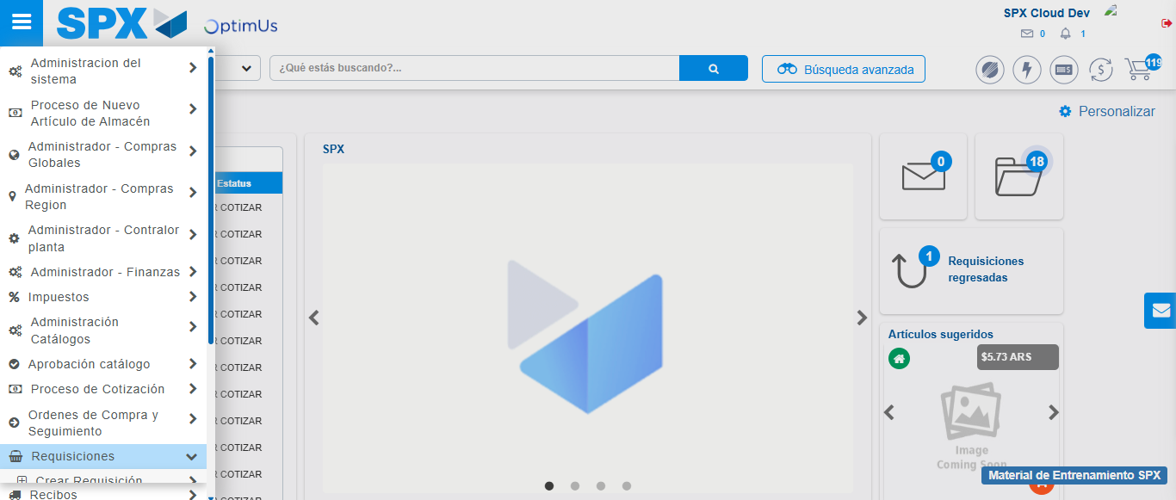Image file-name: QC_Testing-runTestMultipleTimes-nov. 25 2025, 03 47 52 p. m.

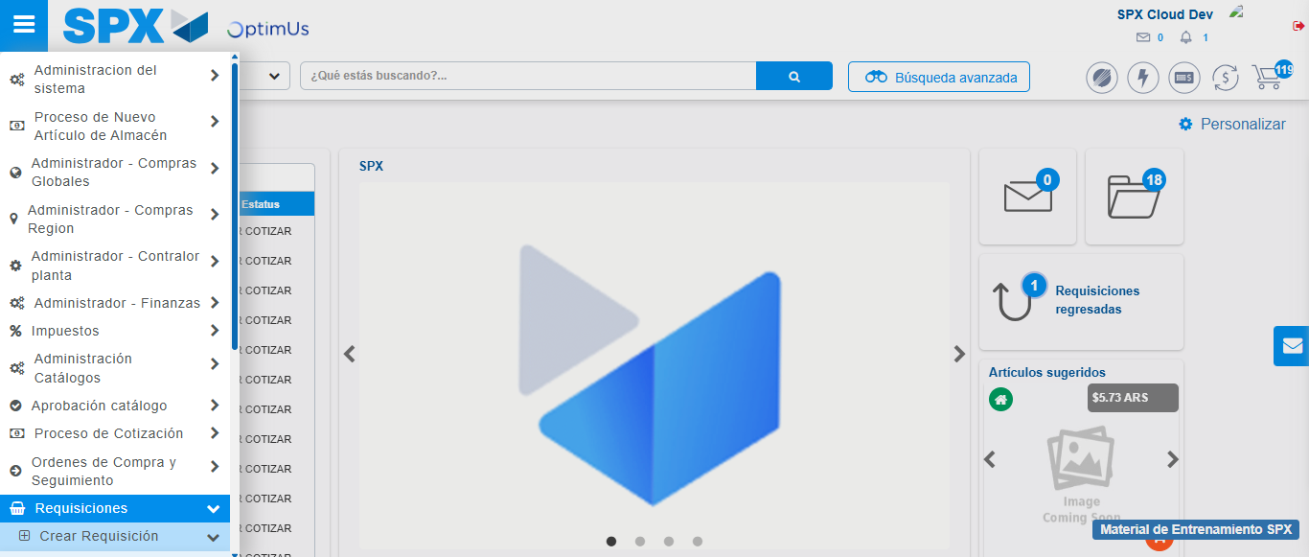Image file-name: QC_Testing-runTestMultipleTimes-nov. 25 2025, 03 47 53 p. m.

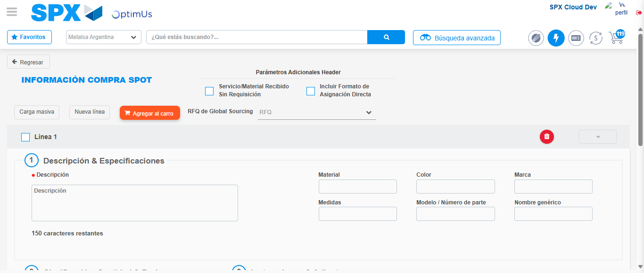Image file-name: QC_Testing-runTestMultipleTimes-nov. 25 2025, 03 47 56 p. m.

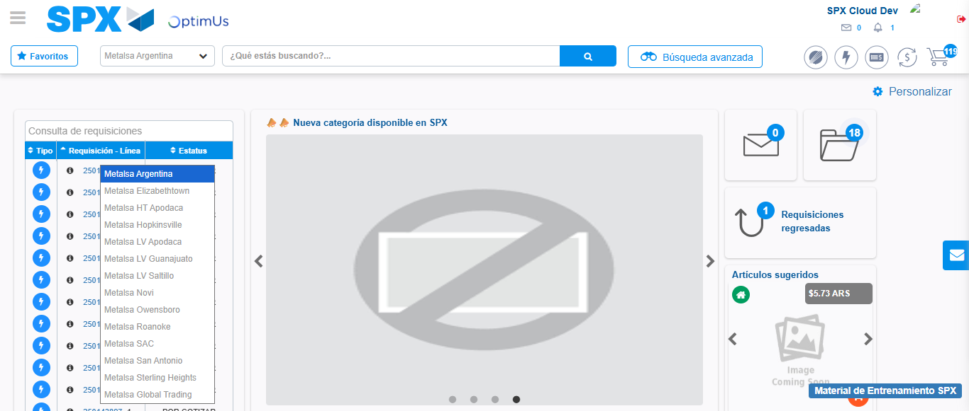Image file-name: QC_Testing-runTestMultipleTimes-nov. 25 2025, 03 49 21 p. m.

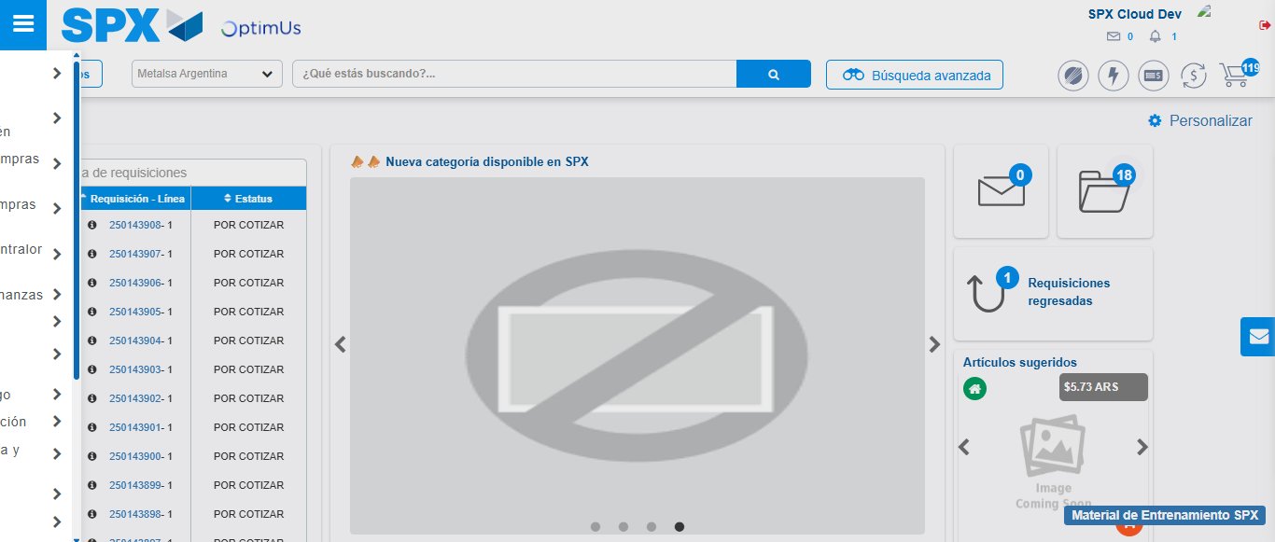Image file-name: QC_Testing-runTestMultipleTimes-nov. 25 2025, 03 49 22 p. m.

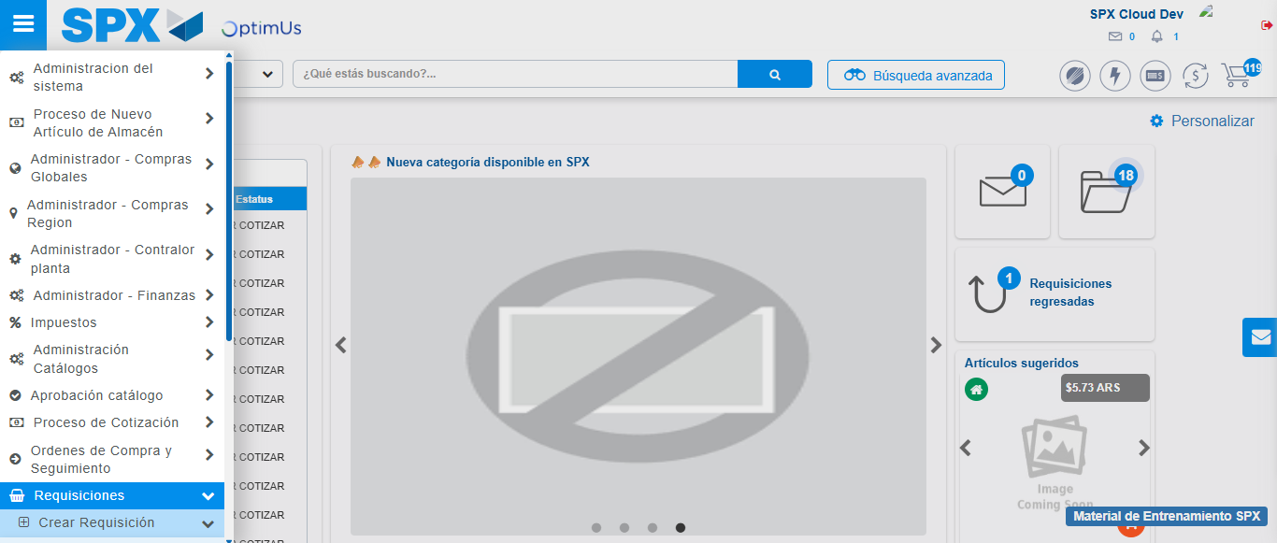Image file-name: QC_Testing-runTestMultipleTimes-nov. 25 2025, 03 49 23 p. m.

Image file-name: QC_Testing-runTestMultipleTimes-nov. 25 2025, 03 49 26 p. m.

Step 3 - Data Capture Spot Buy Requisition : Data captured correctly
Image file-name: QC_Testing-runTestMultipleTimes-nov. 25 2025, 03 47 56 p. m.

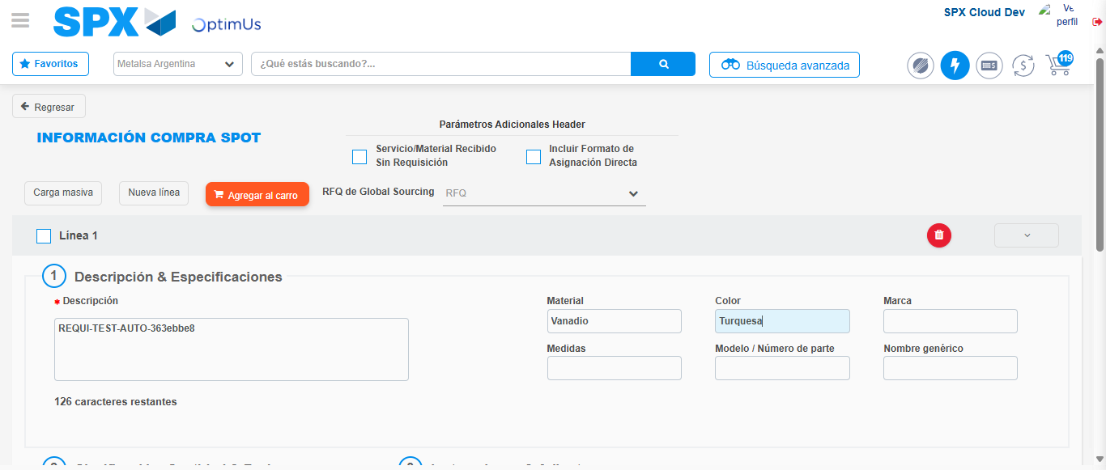Image file-name: QC_Testing-runTestMultipleTimes-nov. 25 2025, 03 47 57 p. m.

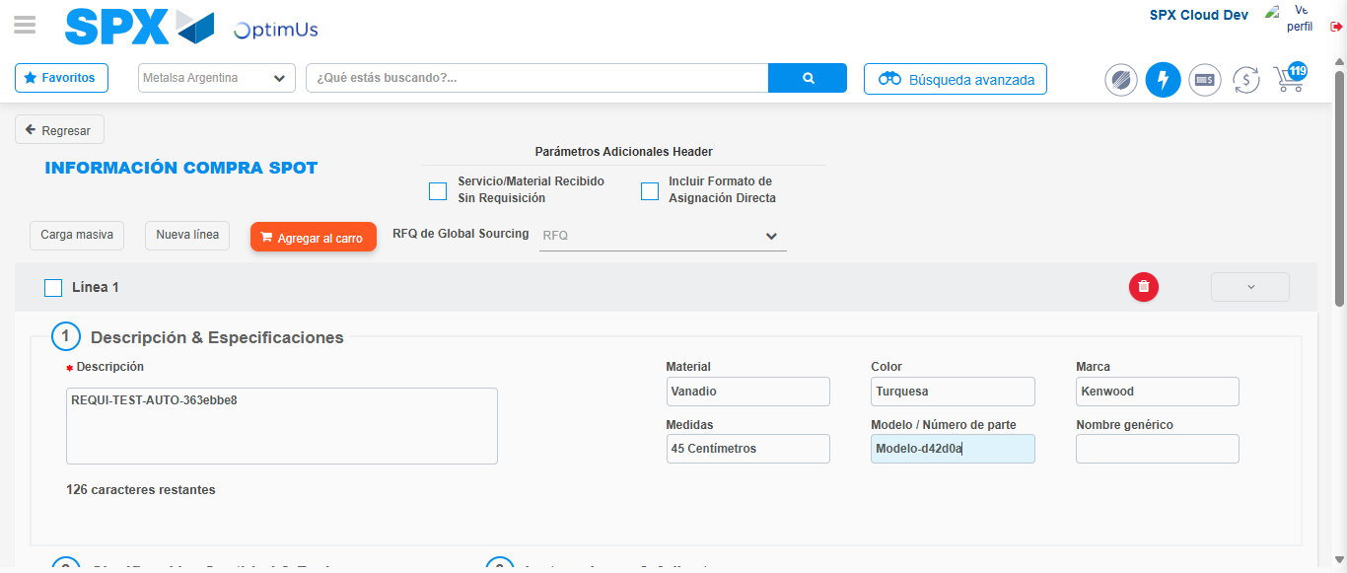Image file-name: QC_Testing-runTestMultipleTimes-nov. 25 2025, 03 47 58 p. m.

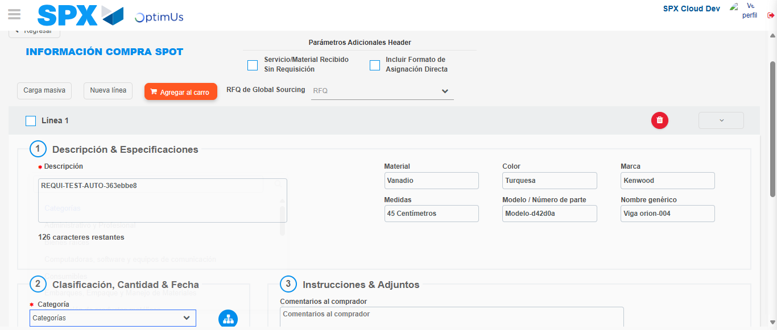Image file-name: QC_Testing-runTestMultipleTimes-nov. 25 2025, 03 47 59 p. m.

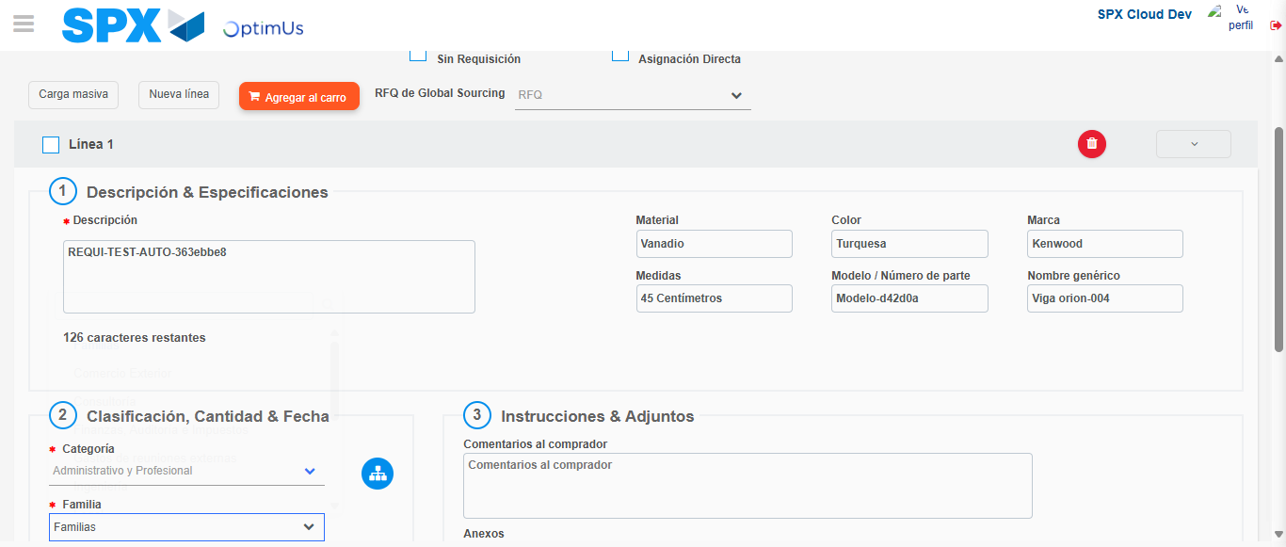Image file-name: QC_Testing-runTestMultipleTimes-nov. 25 2025, 03 48 00 p. m.

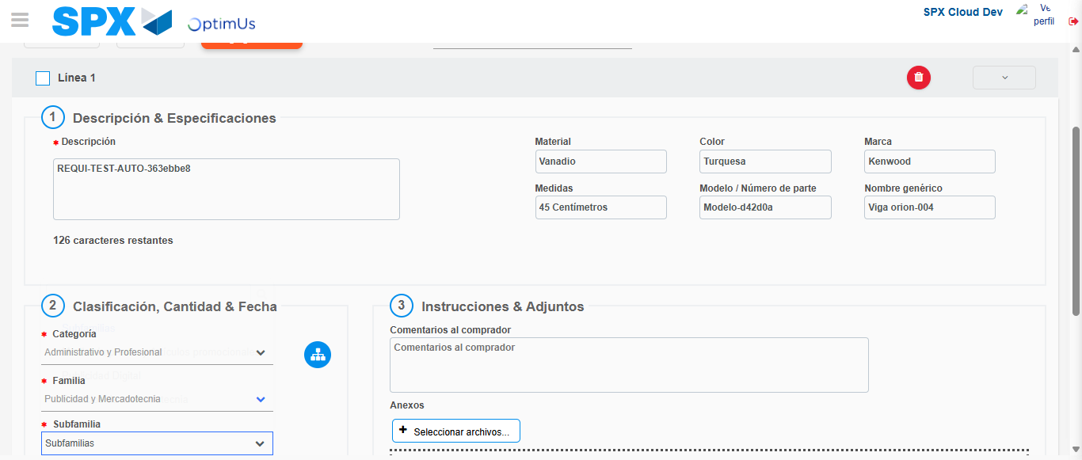Image file-name: QC_Testing-runTestMultipleTimes-nov. 25 2025, 03 48 01 p. m.

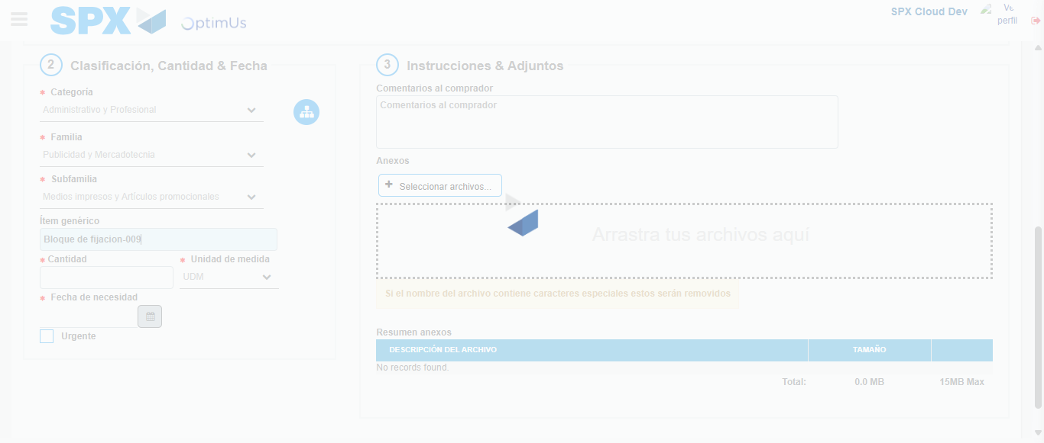Image file-name: QC_Testing-runTestMultipleTimes-nov. 25 2025, 03 48 02 p. m.

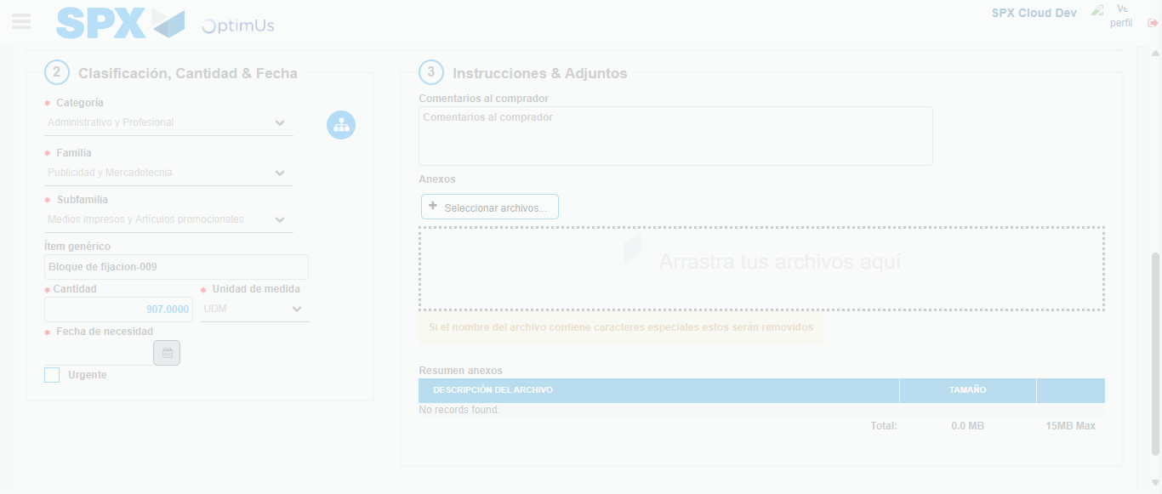Image file-name: QC_Testing-runTestMultipleTimes-nov. 25 2025, 03 48 03 p. m.

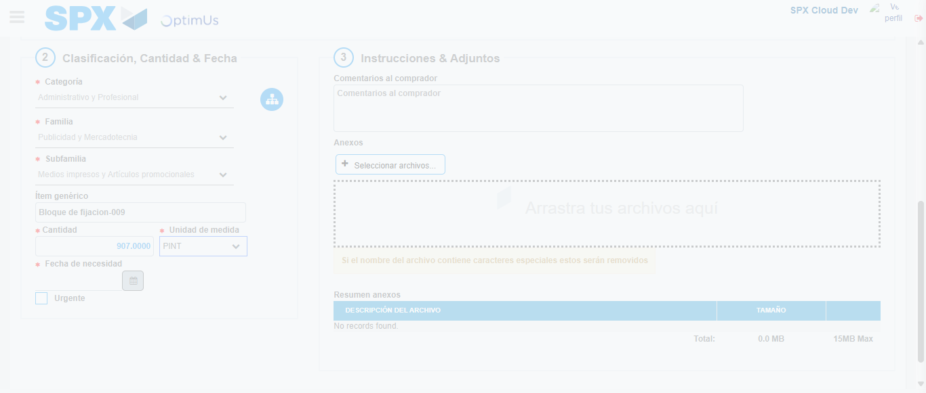Image file-name: QC_Testing-runTestMultipleTimes-nov. 25 2025, 03 48 04 p. m.

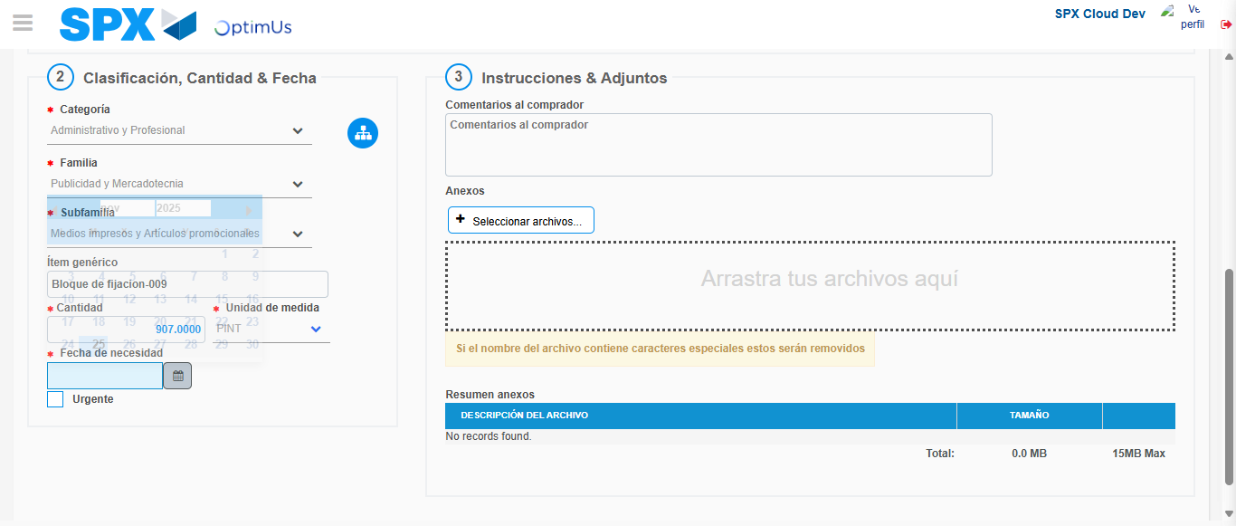Image file-name: QC_Testing-runTestMultipleTimes-nov. 25 2025, 03 48 05 p. m.

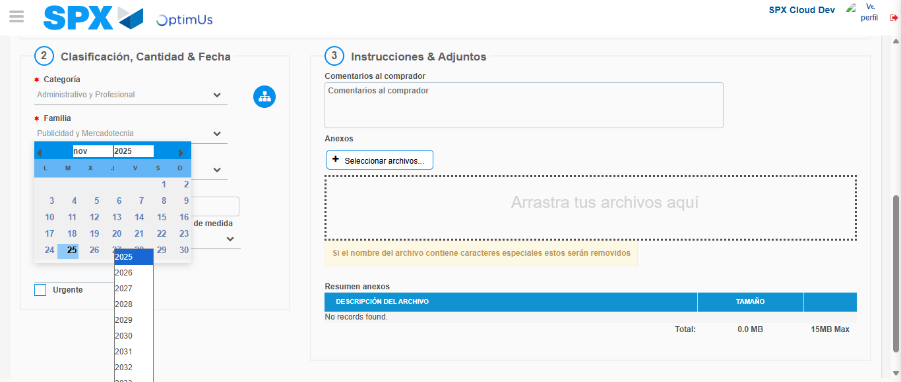Image file-name: QC_Testing-runTestMultipleTimes-nov. 25 2025, 03 48 06 p. m.

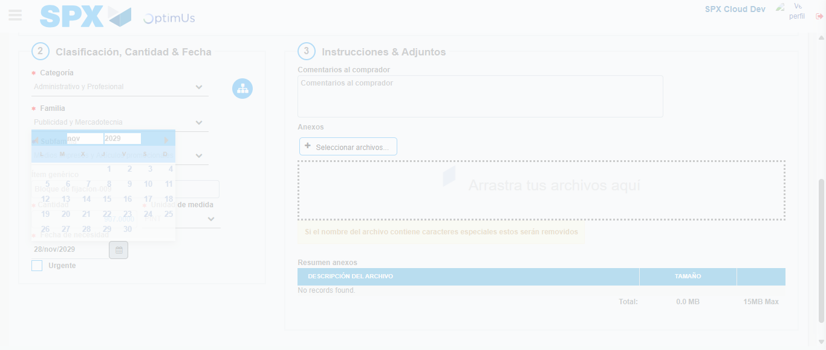Image file-name: QC_Testing-runTestMultipleTimes-nov. 25 2025, 03 48 07 p. m.

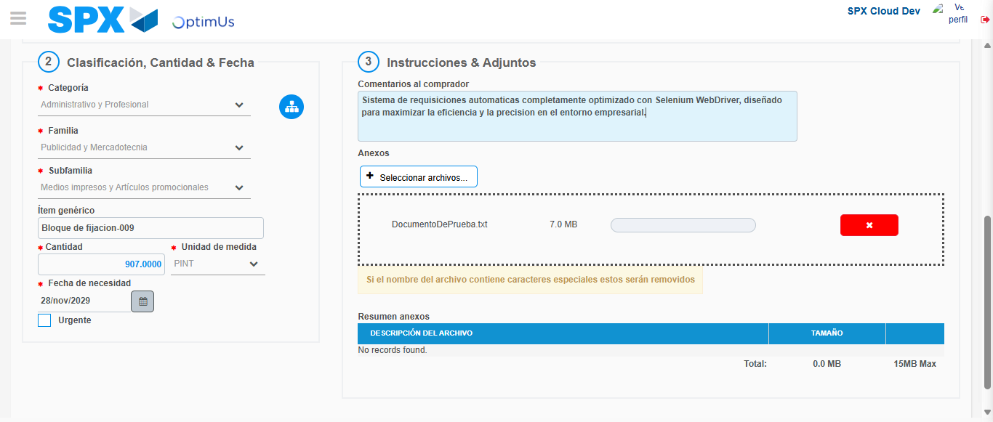Image file-name: QC_Testing-runTestMultipleTimes-nov. 25 2025, 03 48 08 p. m.

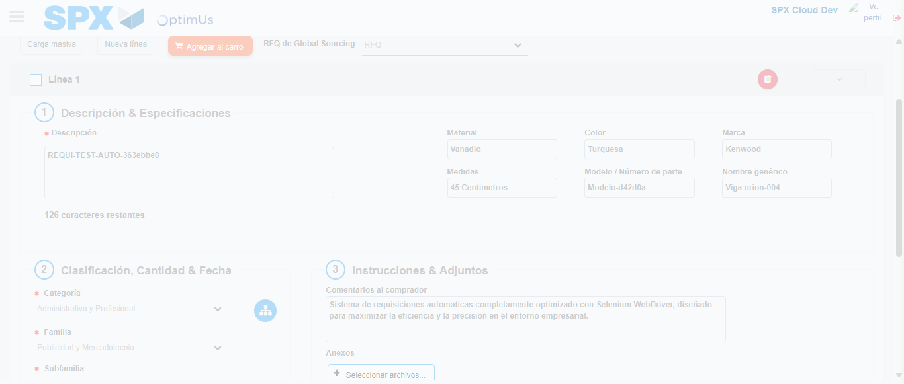Image file-name: QC_Testing-runTestMultipleTimes-nov. 25 2025, 03 48 09 p. m.

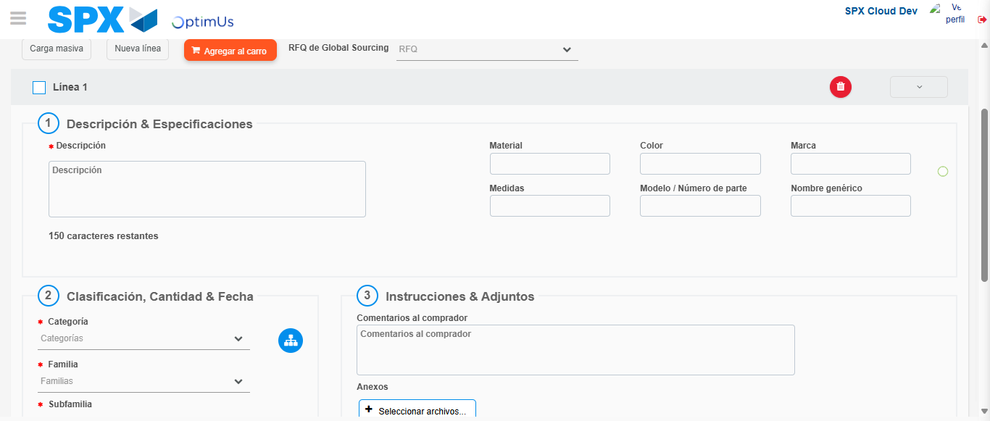Image file-name: QC_Testing-runTestMultipleTimes-nov. 25 2025, 03 48 14 p. m.

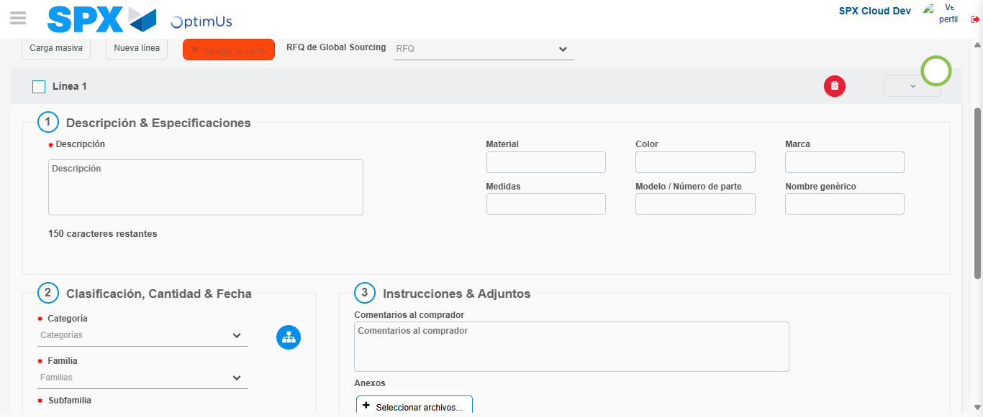Image file-name: QC_Testing-runTestMultipleTimes-nov. 25 2025, 03 48 15 p. m.

Image file-name: QC_Testing-runTestMultipleTimes-nov. 25 2025, 03 49 26 p. m.

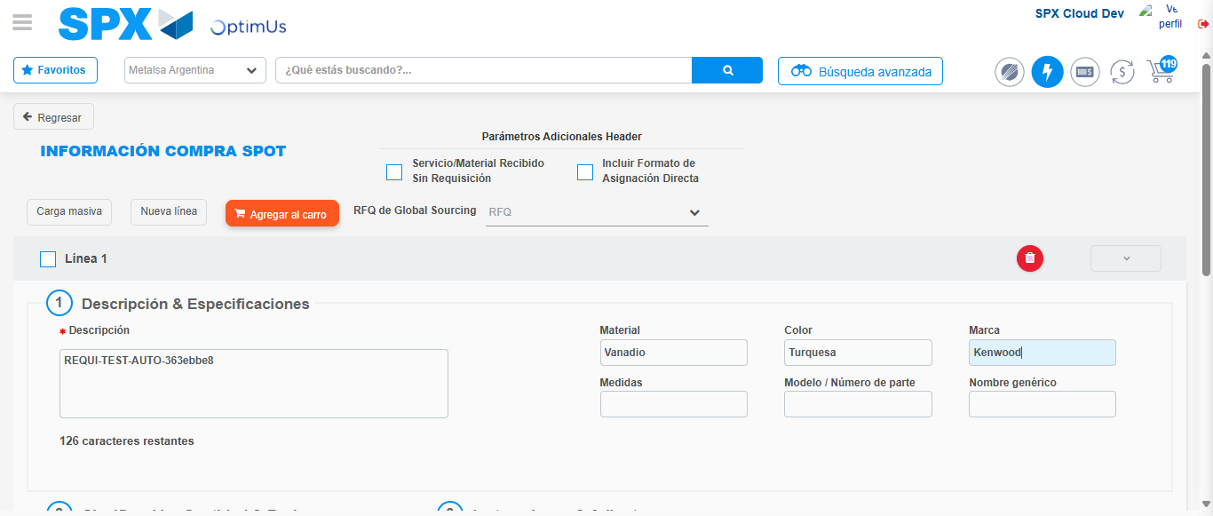Image file-name: QC_Testing-runTestMultipleTimes-nov. 25 2025, 03 49 27 p. m.

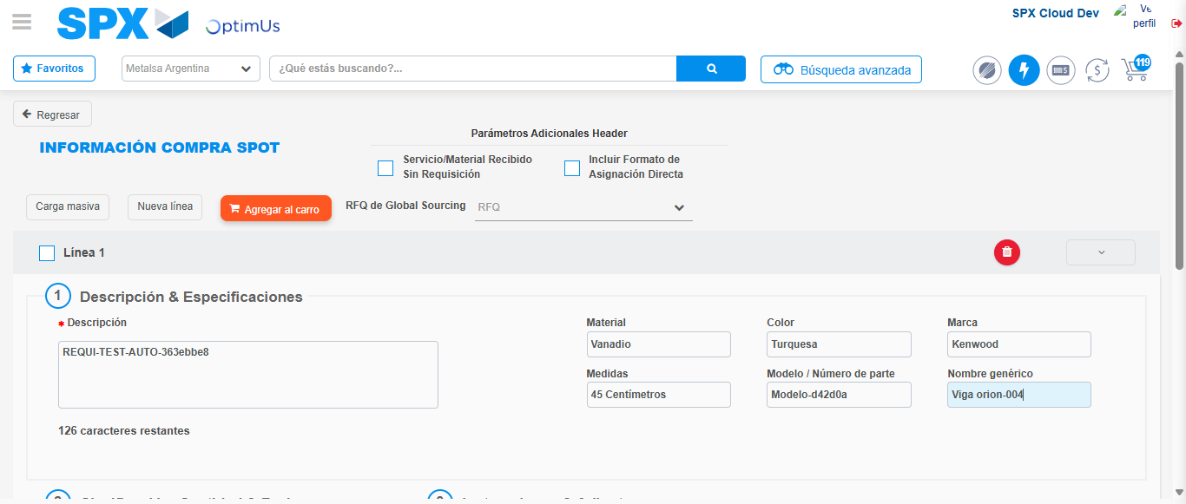Image file-name: QC_Testing-runTestMultipleTimes-nov. 25 2025, 03 49 28 p. m.

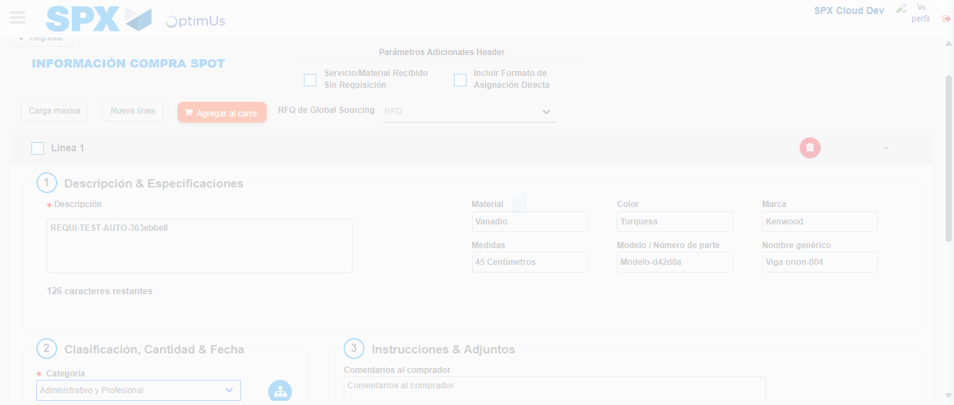Image file-name: QC_Testing-runTestMultipleTimes-nov. 25 2025, 03 49 29 p. m.

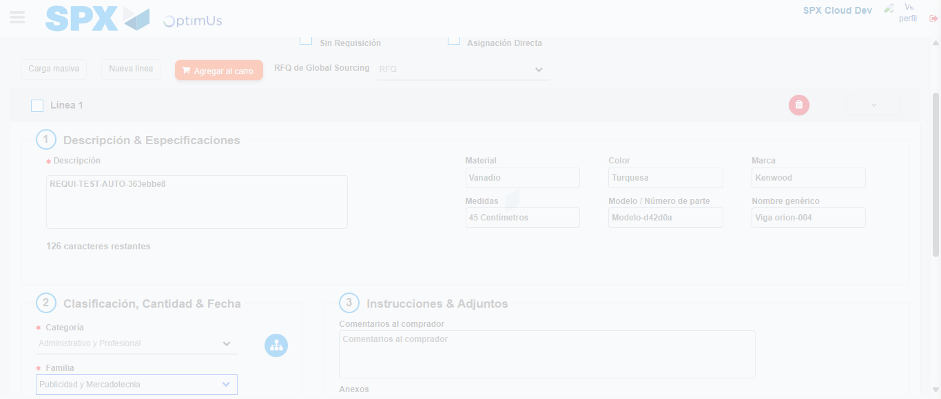Image file-name: QC_Testing-runTestMultipleTimes-nov. 25 2025, 03 49 30 p. m.

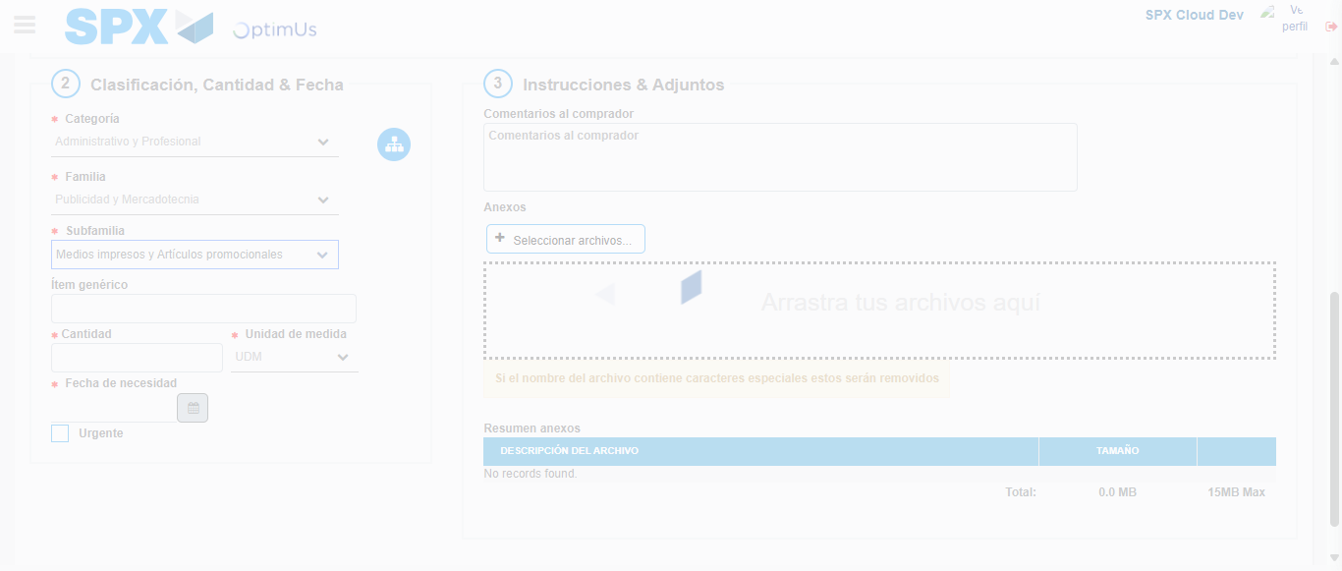Image file-name: QC_Testing-runTestMultipleTimes-nov. 25 2025, 03 49 31 p. m.

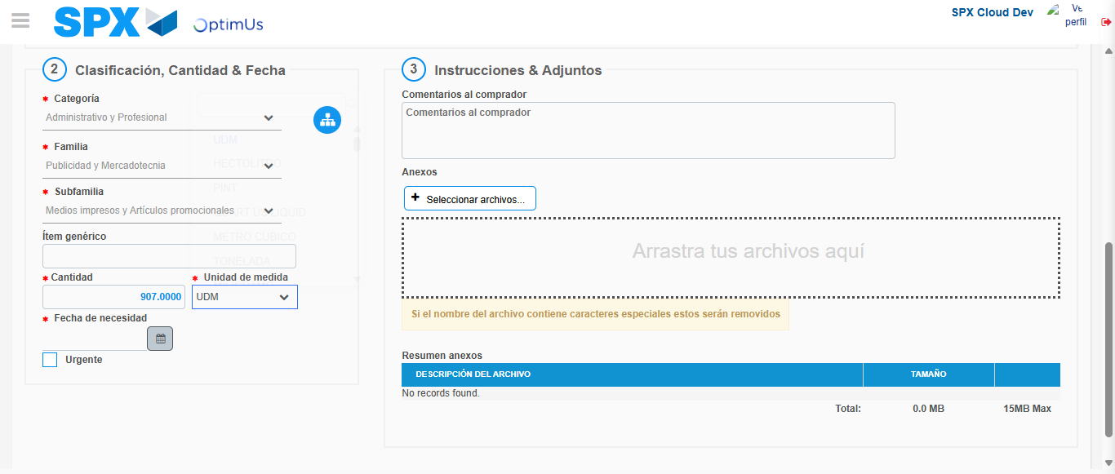Image file-name: QC_Testing-runTestMultipleTimes-nov. 25 2025, 03 49 32 p. m.

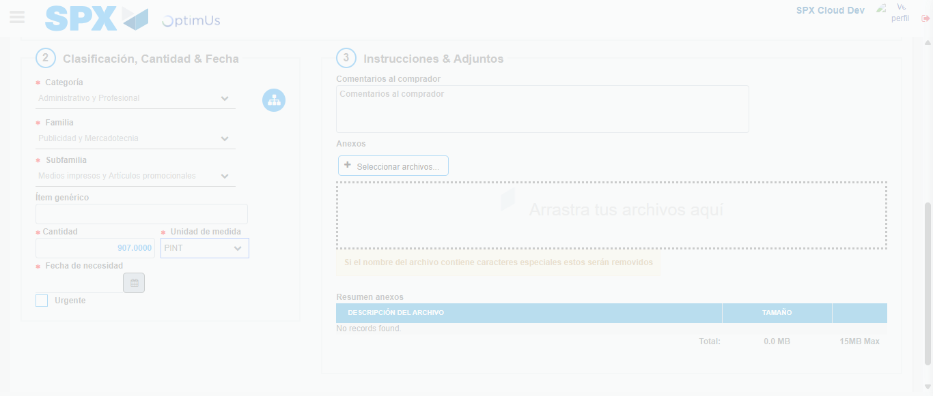Image file-name: QC_Testing-runTestMultipleTimes-nov. 25 2025, 03 49 33 p. m.

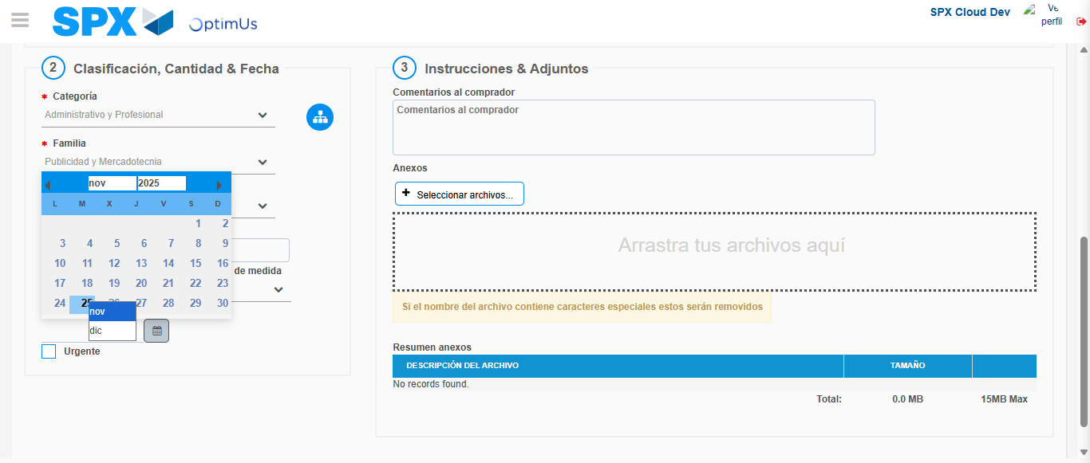Image file-name: QC_Testing-runTestMultipleTimes-nov. 25 2025, 03 49 34 p. m.

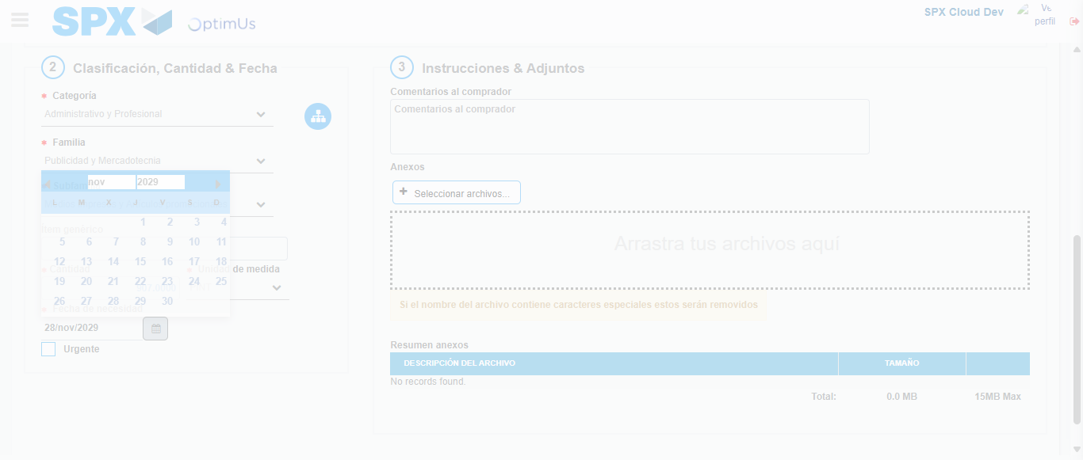Image file-name: QC_Testing-runTestMultipleTimes-nov. 25 2025, 03 49 35 p. m.

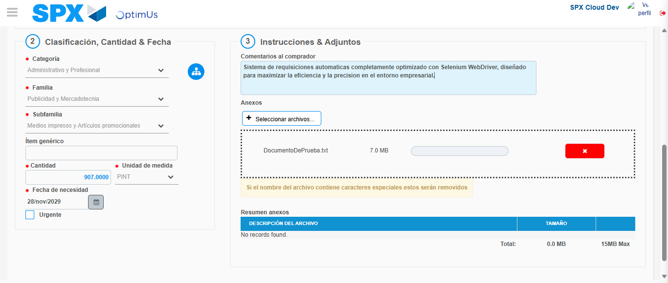Image file-name: QC_Testing-runTestMultipleTimes-nov. 25 2025, 03 49 36 p. m.

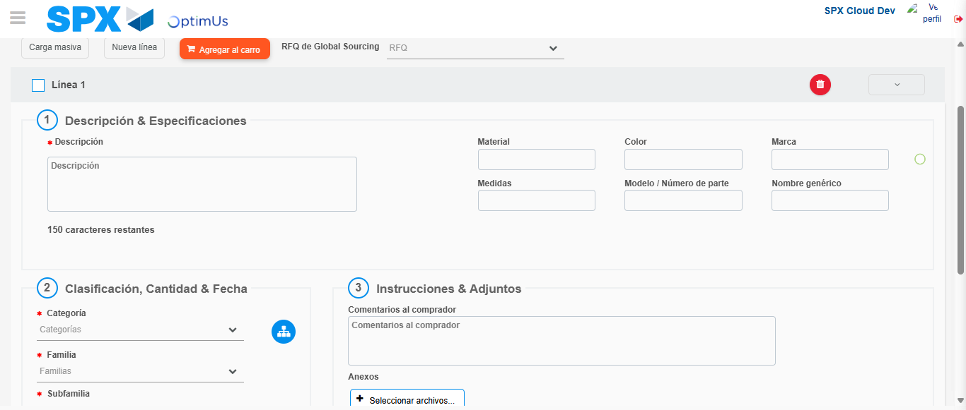Image file-name: QC_Testing-runTestMultipleTimes-nov. 25 2025, 03 49 37 p. m.

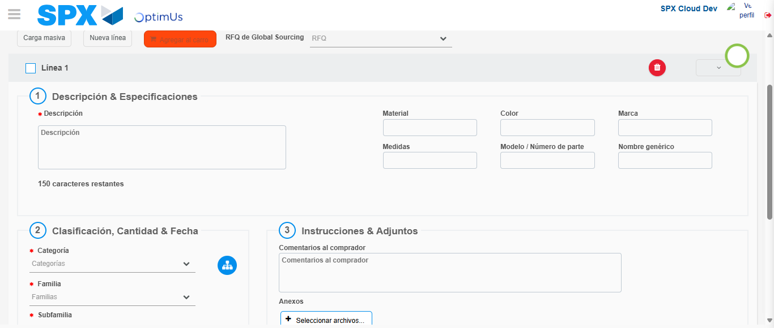Image file-name: QC_Testing-runTestMultipleTimes-nov. 25 2025, 03 49 38 p. m.

Step 4 - Select to Requisition : Requisition Correctly selected
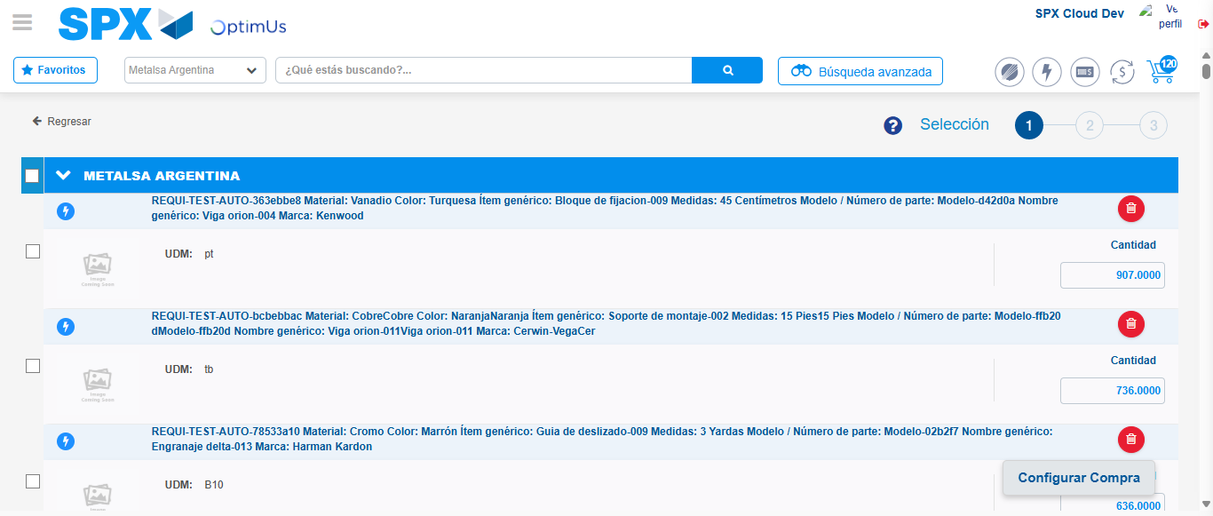Image file-name: QC_Testing-runTestMultipleTimes-nov. 25 2025, 03 48 24 p. m.

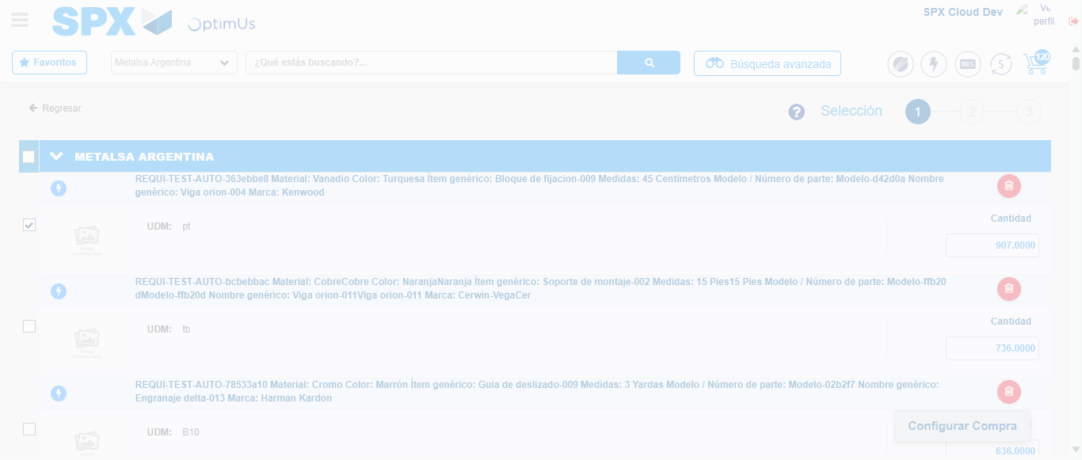Image file-name: QC_Testing-runTestMultipleTimes-nov. 25 2025, 03 48 25 p. m.

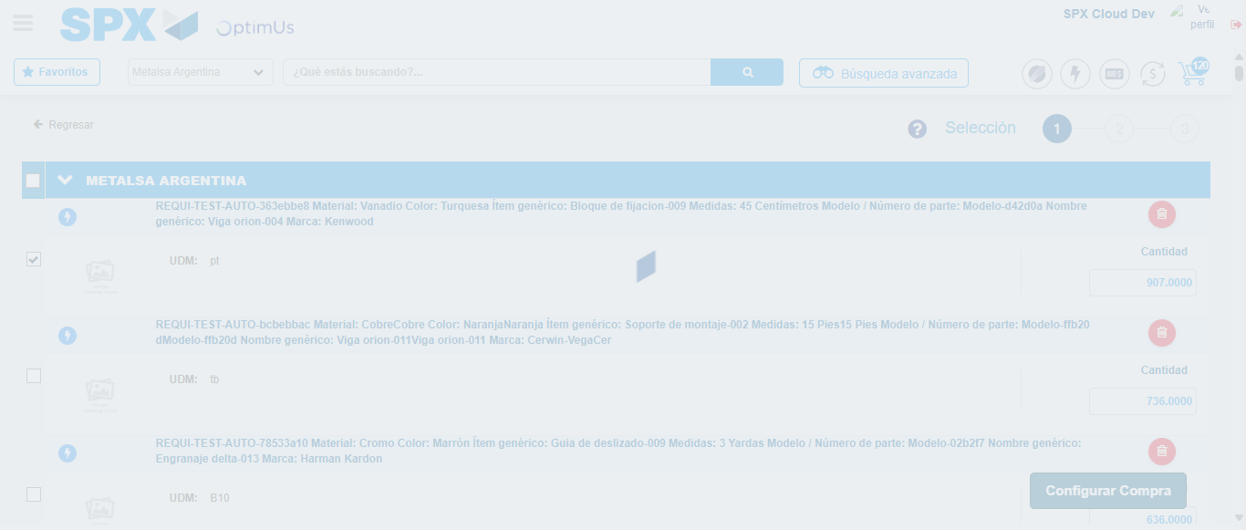Image file-name: QC_Testing-runTestMultipleTimes-nov. 25 2025, 03 48 28 p. m.

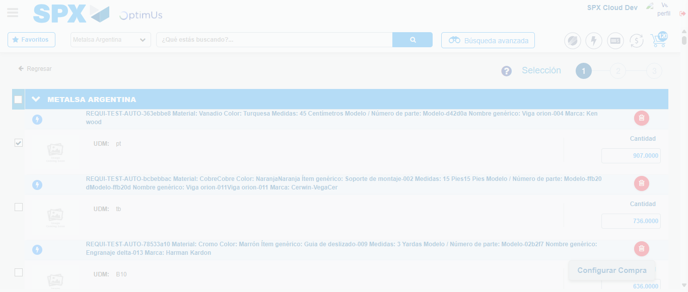Image file-name: QC_Testing-runTestMultipleTimes-nov. 25 2025, 03 49 49 p. m.

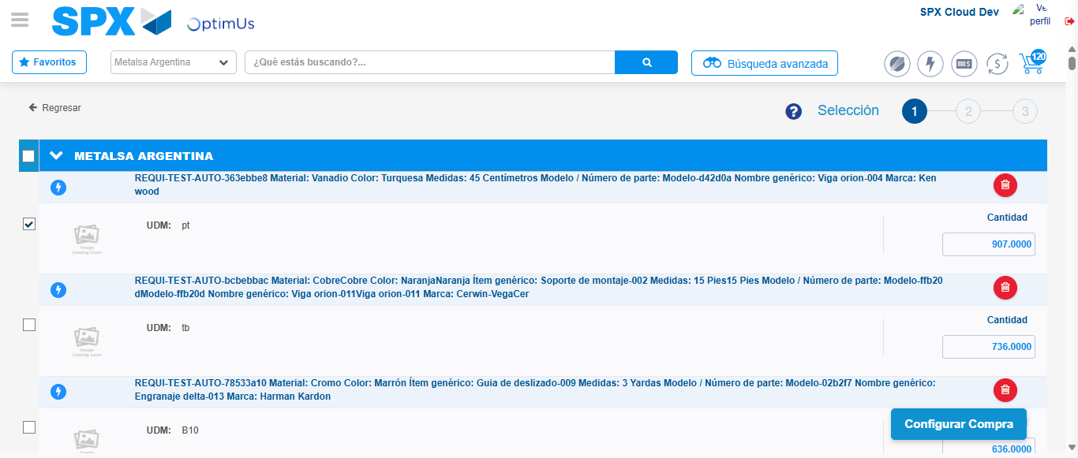Image file-name: QC_Testing-runTestMultipleTimes-nov. 25 2025, 03 49 52 p. m.

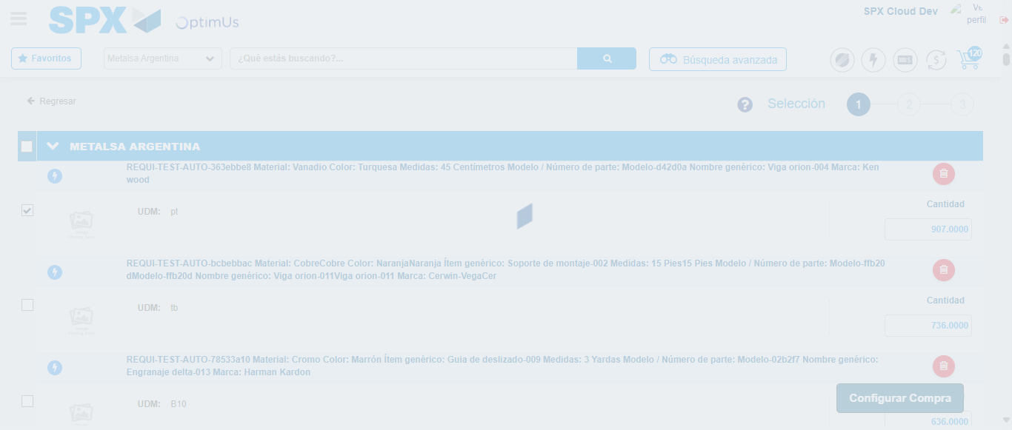Image file-name: QC_Testing-runTestMultipleTimes-nov. 25 2025, 03 49 53 p. m.

Step 5 - Select Type Account For Requisition : Type Account Correctly selected
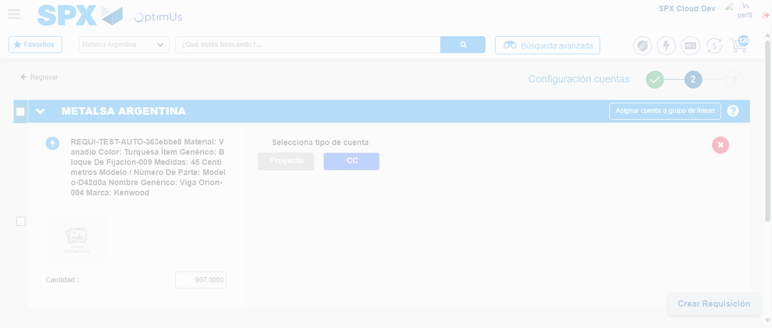Image file-name: QC_Testing-runTestMultipleTimes-nov. 25 2025, 03 48 31 p. m.

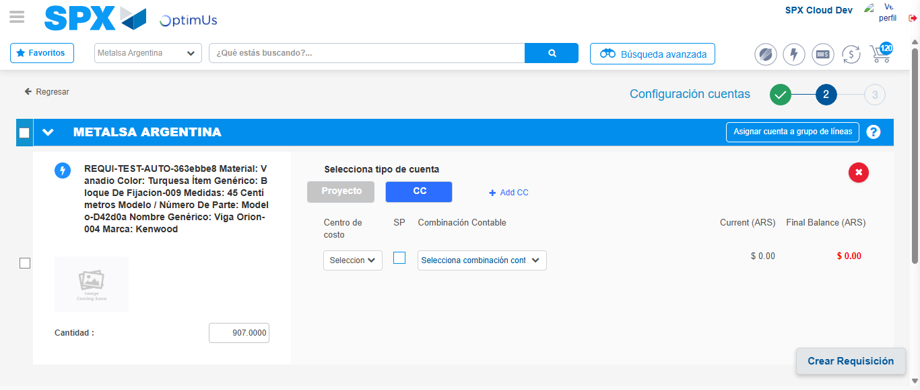Image file-name: QC_Testing-runTestMultipleTimes-nov. 25 2025, 03 48 34 p. m.

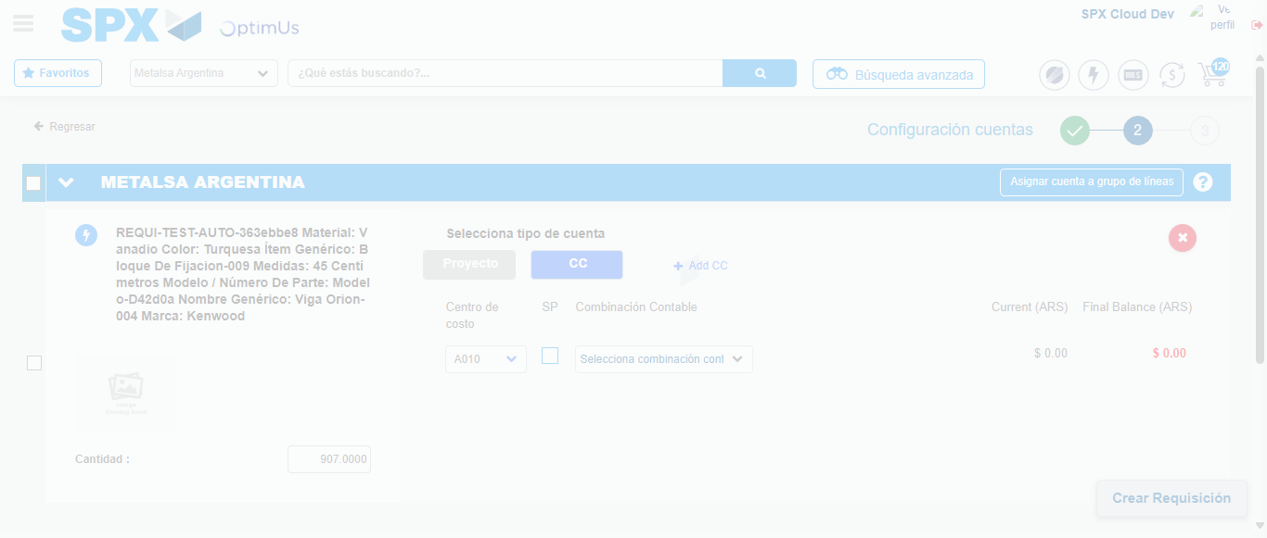Image file-name: QC_Testing-runTestMultipleTimes-nov. 25 2025, 03 48 38 p. m.

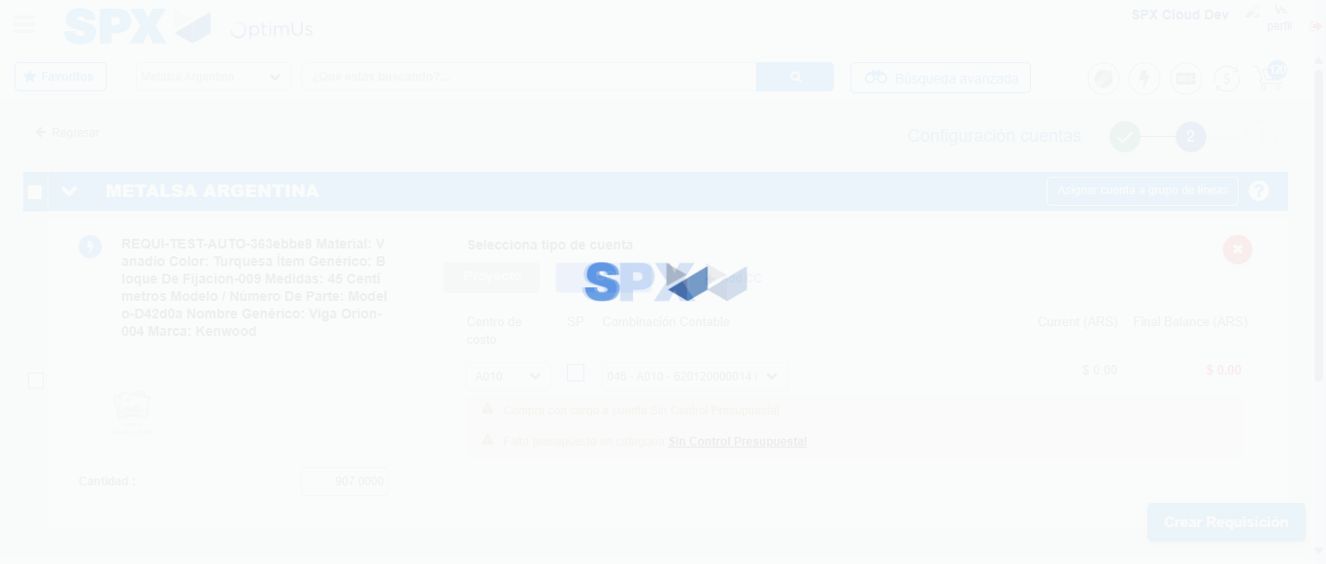Image file-name: QC_Testing-runTestMultipleTimes-nov. 25 2025, 03 48 41 p. m.

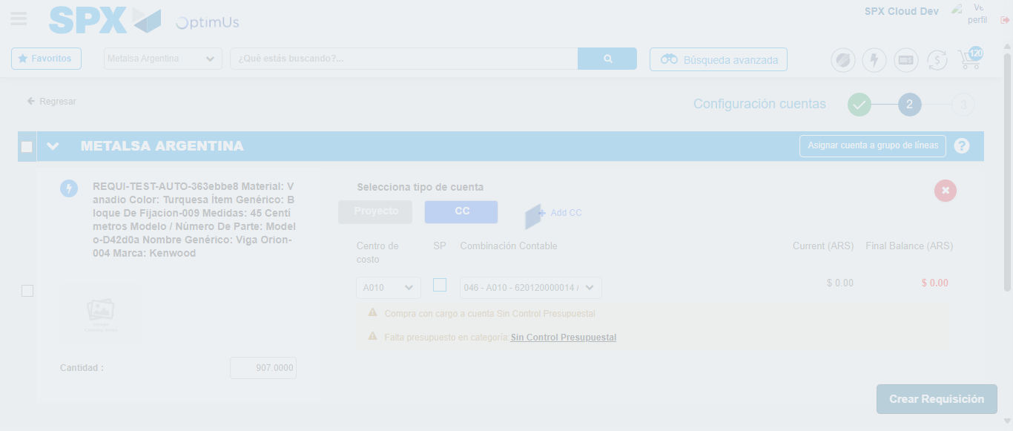Image file-name: QC_Testing-runTestMultipleTimes-nov. 25 2025, 03 48 42 p. m.

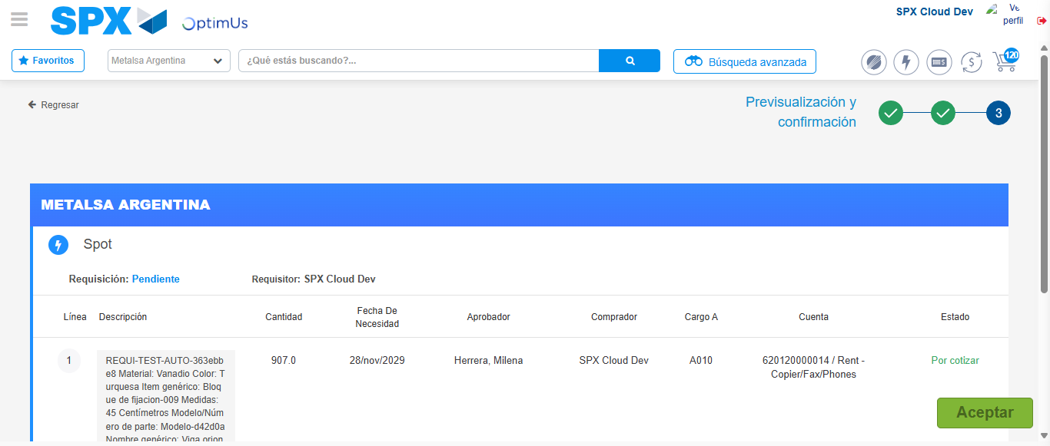Image file-name: QC_Testing-runTestMultipleTimes-nov. 25 2025, 03 48 45 p. m.

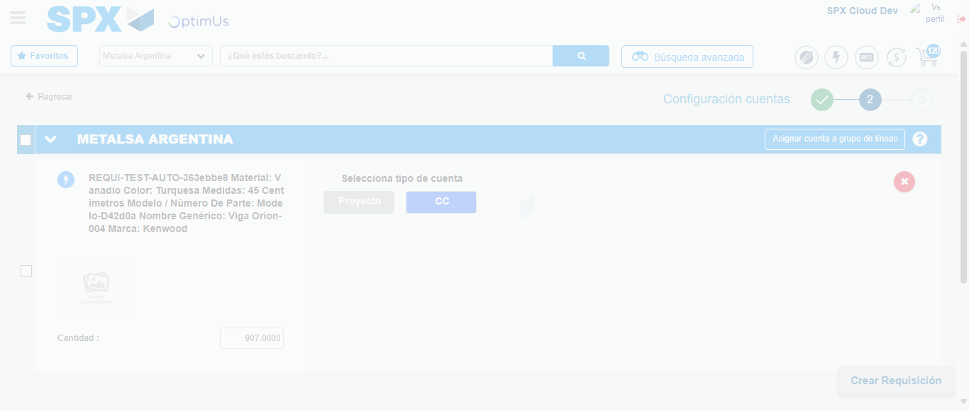Image file-name: QC_Testing-runTestMultipleTimes-nov. 25 2025, 03 49 56 p. m.

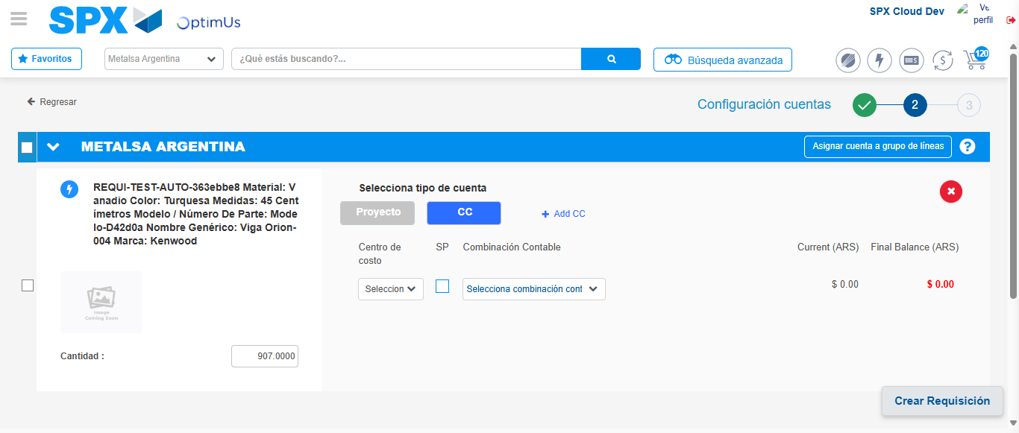Image file-name: QC_Testing-runTestMultipleTimes-nov. 25 2025, 03 49 59 p. m.

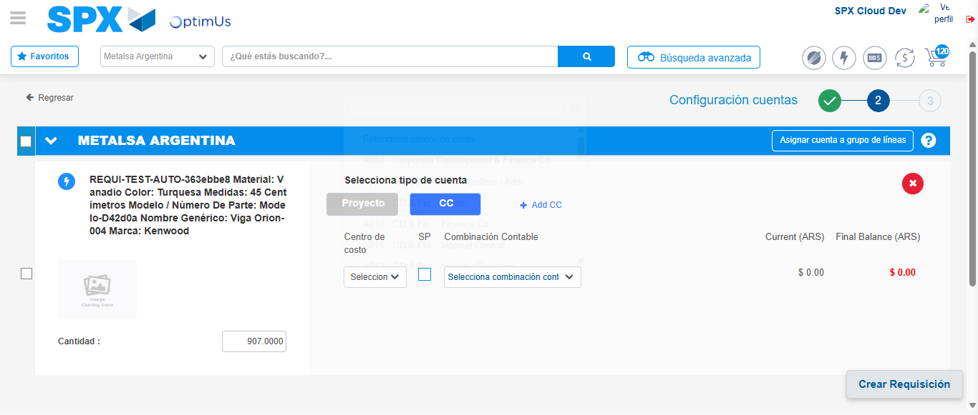Image file-name: QC_Testing-runTestMultipleTimes-nov. 25 2025, 03 50 02 p. m.

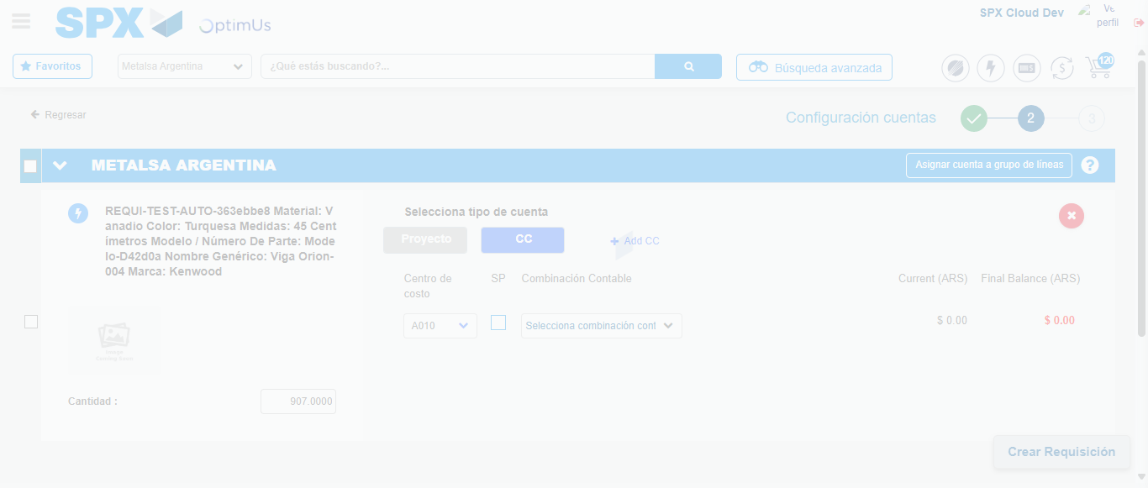Image file-name: QC_Testing-runTestMultipleTimes-nov. 25 2025, 03 50 03 p. m.

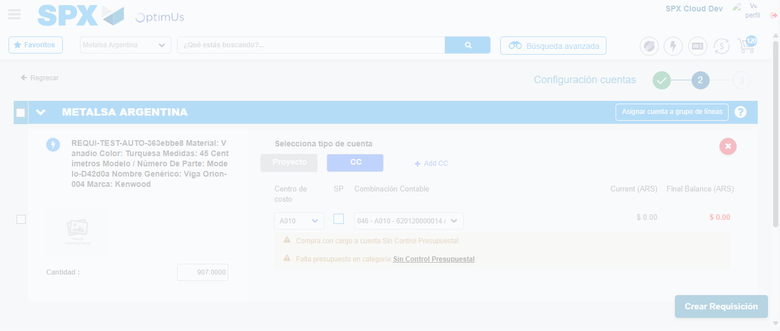Image file-name: QC_Testing-runTestMultipleTimes-nov. 25 2025, 03 50 06 p. m.

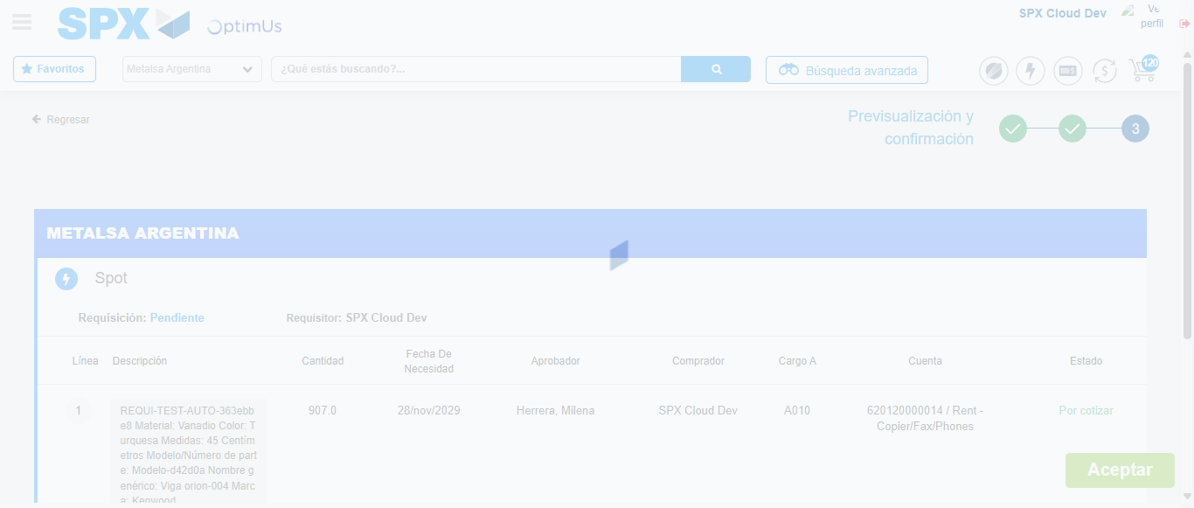Image file-name: QC_Testing-runTestMultipleTimes-nov. 25 2025, 03 50 07 p. m.

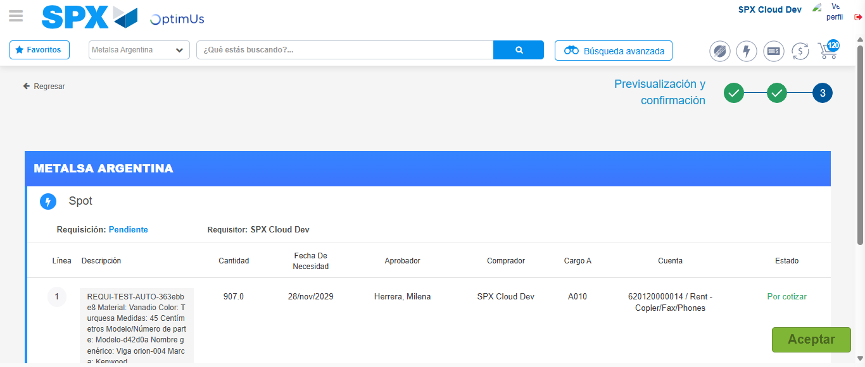Image file-name: QC_Testing-runTestMultipleTimes-nov. 25 2025, 03 50 10 p. m.

Step 6 - Accept to Requisition : Requisition Accepted
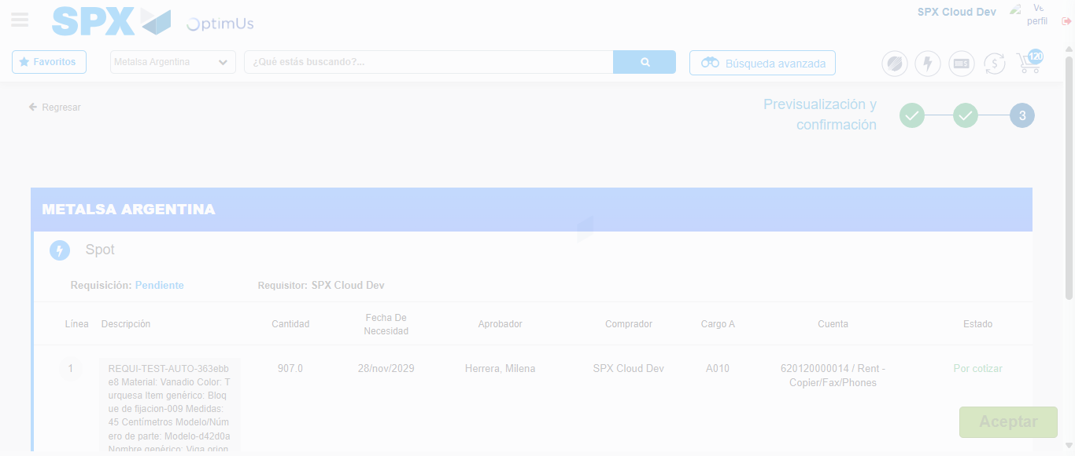Image file-name: QC_Testing-runTestMultipleTimes-nov. 25 2025, 03 48 46 p. m.

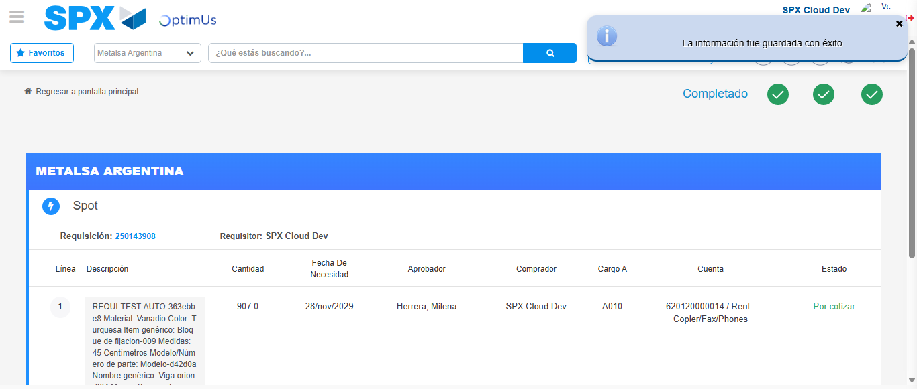Image file-name: QC_Testing-runTestMultipleTimes-nov. 25 2025, 03 48 49 p. m.

Image file-name: QC_Testing-runTestMultipleTimes-nov. 25 2025, 03 50 10 p. m.

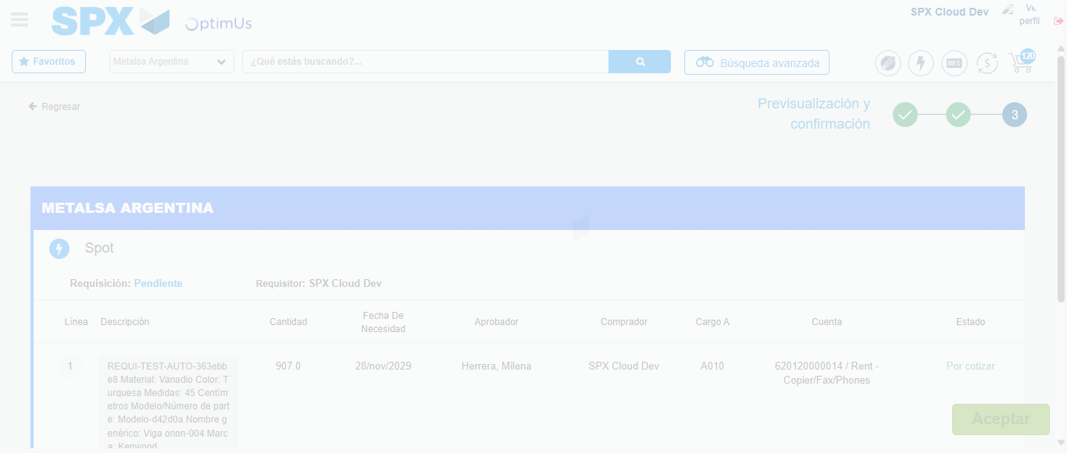Image file-name: QC_Testing-runTestMultipleTimes-nov. 25 2025, 03 50 11 p. m.

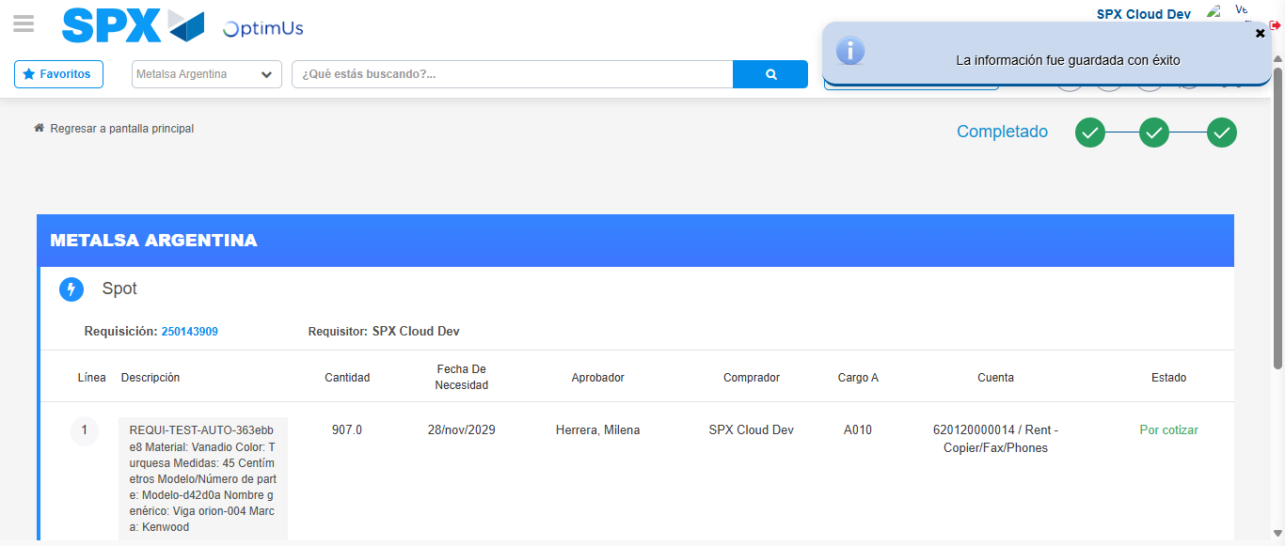Image file-name: QC_Testing-runTestMultipleTimes-nov. 25 2025, 03 50 14 p. m.

